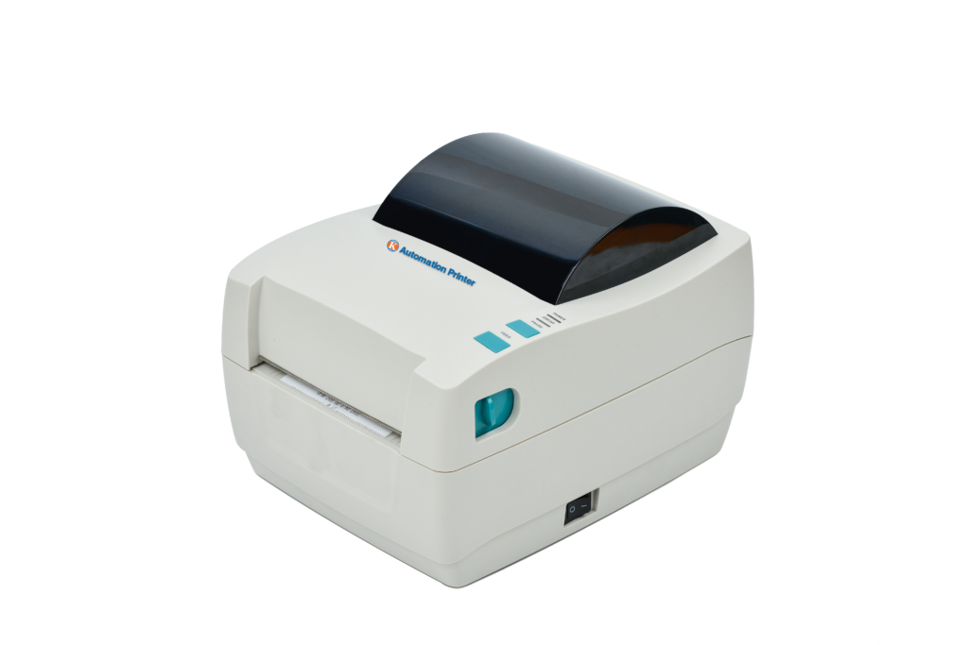

AirPrinter

User’s Guide

Thank you for purchasing AirPrinter, It has high printing speed, low noise, high reliability, high printing quality, and ribbon needless to avoid daily maintenance trouble. TL51 is a small, simple operating method and has a wide application field, especially for business fields like warehousing, logistics, courier express, etc.

packing&delivery

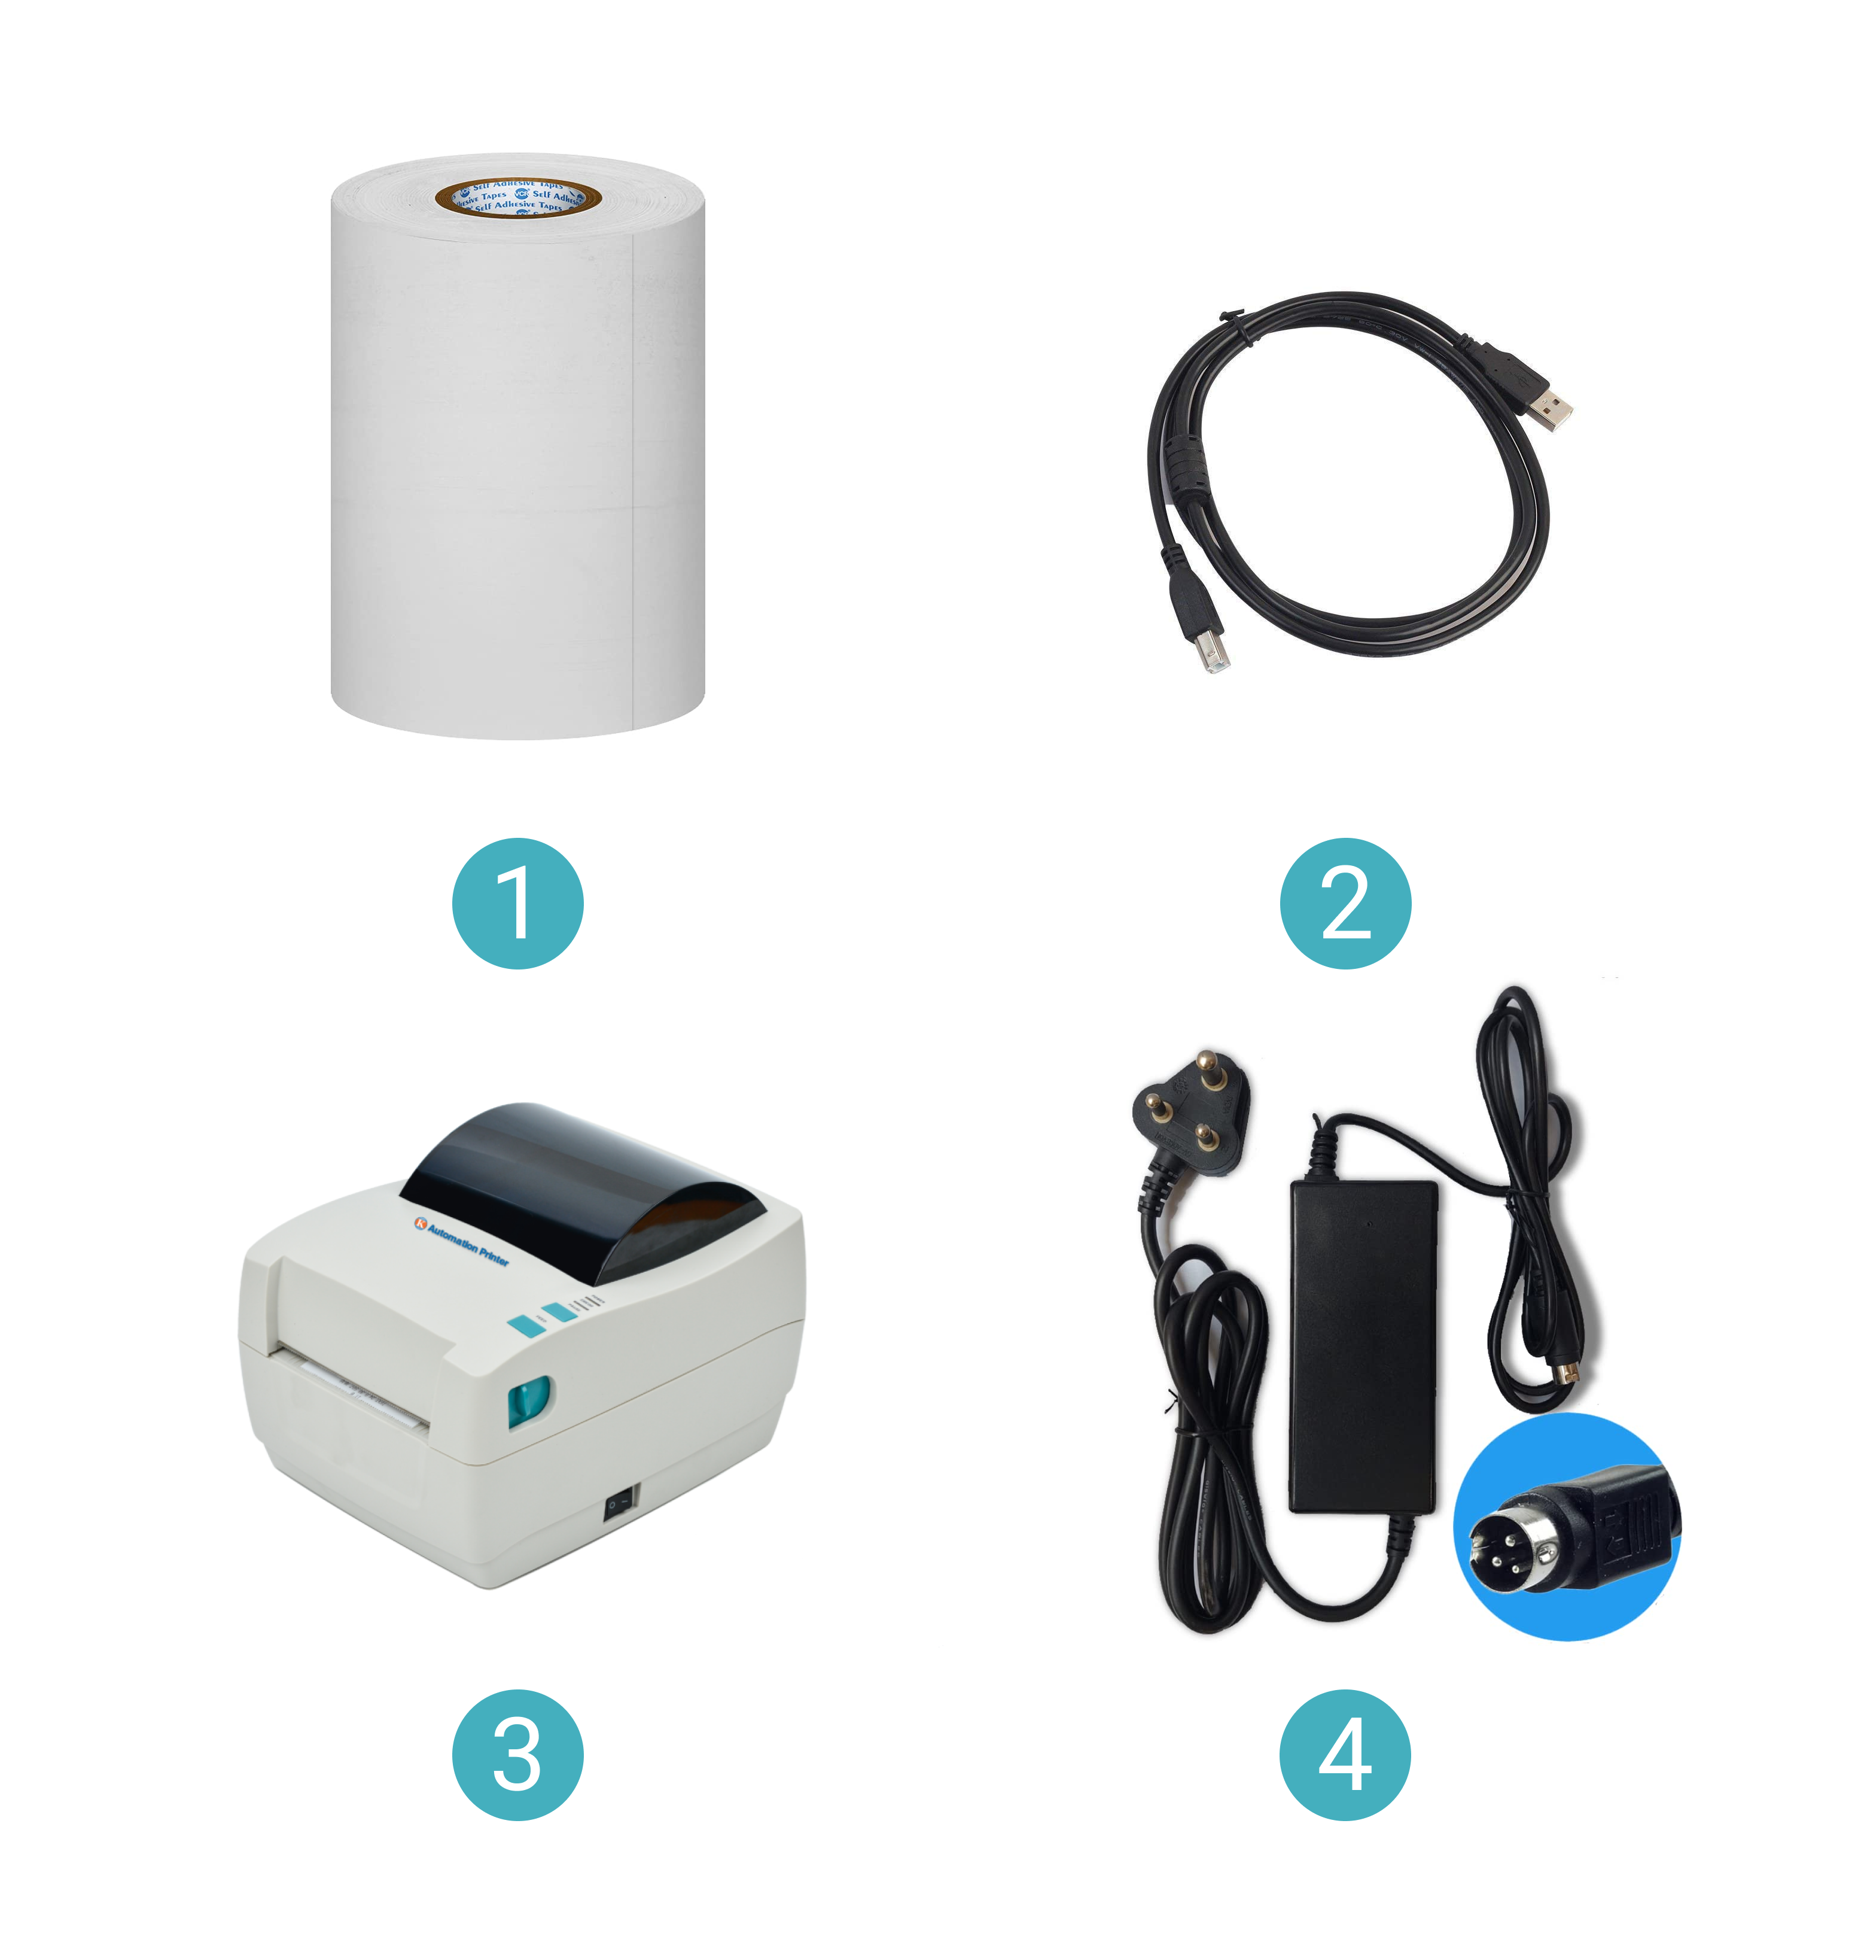

No | Names and Specifications of Goods | QTY
1. | Test Paper | 1
2. | Interface Cable | 1
3. | Printer | 1
4. | Power Supply | 1

Specification

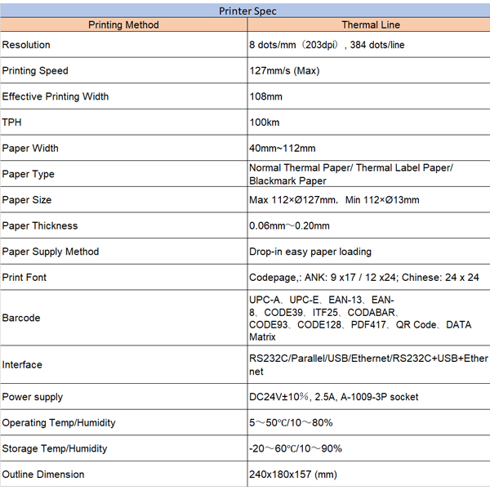

Printer appearance

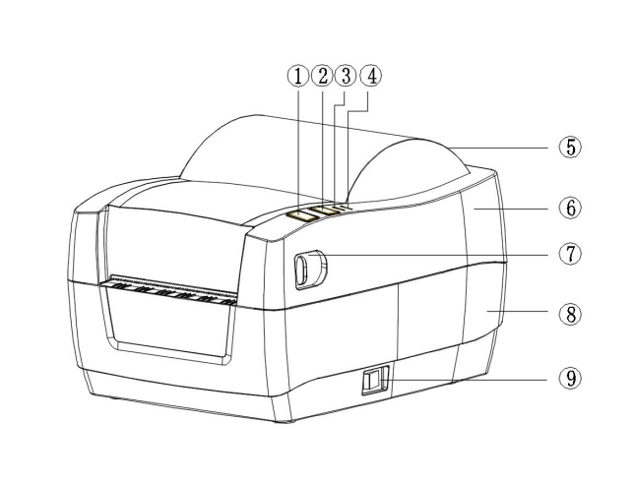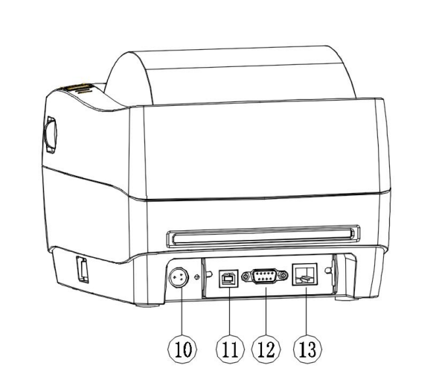

1. Feed button
2. Pause button
3. Error light indicator
4. Power light indicator
5. Transparent paper house
6. Top enclosure body
7. Cover open button
8. Bottom enclosure body
9. Power switch
10. Power socket
11. USB interface
12. DB9 serial interface
13. Ethernet interface

1. Feed Button
Located on the printer's interface panel, the Feed Button provides manual control over paper feeding.
- Functionality: When pressed, it advances the paper roll forward to adjust paper alignment or feed blank paper out of the printer.
- Use Cases: Ideal for testing print alignment, removing unused portions of the paper roll, or ensuring proper paper positioning during setup.

2. Pause Button
The Pause Button is an essential operational control that halts the printing process temporarily.
- Functionality: Suspends printing without canceling the job, allowing the user to resume later.
- Use Cases: Useful in cases where adjustments are needed or interruptions occur during printing.

3. Error Light Indicator
A bright, attention-grabbing Error Indicator Light designed to signal issues.
- Functionality: Displays various error statuses like paper jams, low paper, or overheating, using color codes or blinking patterns.
- Benefits: Promotes efficient troubleshooting by giving users immediate visual feedback.

4. Power Light Indicator
The Power Light Indicator provides a clear visual cue when the printer is active.
- Functionality: Illuminates steadily when the printer is powered on and operating normally.
- Design: Positioned prominently to be easily visible in both well-lit and dim environments.

5. Transparent Paper House
The Transparent Paper House is a clear enclosure covering the paper roll compartment.
- Functionality: Enables users to monitor paper levels without opening the printer, reducing interruptions.
- Design: Made of durable, transparent material that offers visibility while protecting the paper from dust and external elements.

6. Top Enclosure Body
The Top Enclosure Body forms the upper part of the printer's casing.
- Material: Constructed from high-quality, impact-resistant plastic or metal to ensure durability.
- Design Features: Sleek and smooth, it houses internal components and provides access points for buttons and indicators.

7. Cover Open Button
The Cover Open Button allows for effortless access to the paper roll compartment.
- Mechanism: A spring-loaded latch that opens the top cover when pressed.
- Use Cases: Simplifies tasks such as loading, replacing, or clearing jammed paper rolls.

8. Bottom Enclosure Body
The Bottom Enclosure Body serves as the foundational structure of the printer.
- Functionality: Supports the entire device, housing key internal components and ensuring stability during operation.
- Design: Engineered for durability, with anti-slip feet to secure the printer in place on various surfaces.

9. Power Switch
The Power Switch is the primary control for turning the printer on or off.
- Design: A rocker or toggle switch located at the back or side for easy access.
- Safety Features: Built with mechanisms to prevent accidental activation, ensuring safe operation.

10. Power Socket
The Power Socket provides the electrical connection for the printer.
- Compatibility: Supports various voltage standards based on regional requirements.
- Design: Firmly secured and durable to handle frequent plug-ins and removals.

11. USB Interface
The USB Interface is a widely used connection port that ensures easy integration with computers and devices.
- Functionality: Offers fast data transfer rates for seamless communication between the printer and host device.
- Use Cases: Commonly used in environments requiring plug-and-play setup.

12. DB9 Serial Interface
The DB9 Serial Interface provides support for older communication protocols.
- Functionality: Ensures compatibility with legacy systems, making the printer versatile in industrial setups.
- Durability: Designed to withstand long-term use in demanding conditions.

13. Ethernet Interface
The Ethernet Interface is a networking port that allows the printer to connect to LANs.
- Functionality: Enables remote printing, device management, and integration with networked systems.
- Advantages: Ideal for shared usage in office or warehouse environments where multiple devices need access to the printer.

